
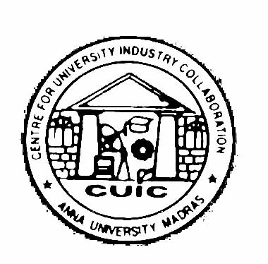
ANNA UNIVERSITY CHENNAI, CHENNAI – 600 025.

CENTRE FOR UNIVERSITY – INDUSTRY COLLABORATION

Application form for Registration / Renewal of
Industrial Associateship Scheme (IAS) 2021

Name and Address of the Organization :

Name of the Chief Executive Officer :

Address for Communication :

Telephone / Fax No./ e-mail / Mobile :

Name of the Representative who will be :
Interacting with CUIC, Anna University
Telephone / Fax No./ e-mail / Mobile

Area of activities : Manufacturing / Service / Educational / R&D / Others (Please √ )

Membership with other industries, if any :

Payment Particulars
Amount : Rs.
Demand Draft No. : Dated :
Bank :
SIGNATURE :

(The Demand Draft for Rs.25,000/- for one calendar year should be drawn in favour of “The Director, CUIC, Anna University – Chennai”, payable at Chennai.)

For further information, Please contact : Dr. MALA JOHN,
Director, CUIC
Phone: 22200599, 22358989
e-mail: cuic.annauniv@gmail.com /
cuic@annauniv.edu

FOR OFFICE USE ONLY

Membership No: Date of Admission:

